姓名：林佑恩 班級：四子三丙  
學號：1103105336老師：陳昭和老師

1. Please make a program for Hough transform using the following algorithm. In the output, the line segments found by Hough transform must be drawn on the original image using the yellow bold line. (Please use C++ based programming language, can’t use Matlab and LabVIEW )

結果：

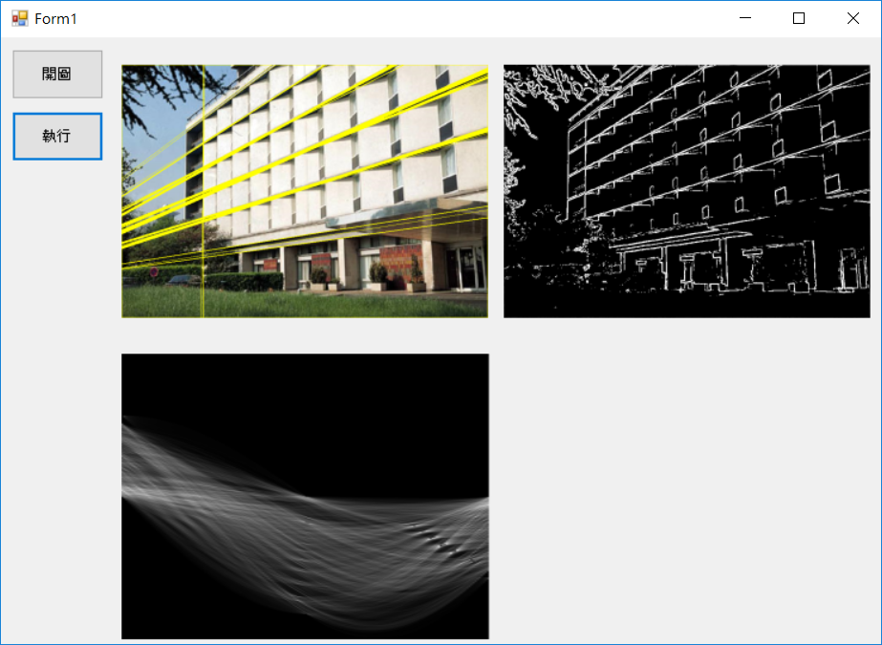

程式碼：

using System;

using System.Collections.Generic;

using System.ComponentModel;

using System.Data;

using System.Drawing;

using System.Linq;

using System.Text;

using System.Threading.Tasks;

using System.Windows.Forms;

using System.Drawing.Imaging;

using System.Windows.Forms.DataVisualization.Charting;

using _20170412_work04_HoughTransform.Properties;

namespace _20170412_work04_HoughTransform

{

public partial class Form1 : Form

{

public Form1()

{

InitializeComponent();

}

Bitmap ori;

private const double Deg2Rad = Math.PI / 90.0;

private void button1_Click(object sender, EventArgs e)

{

OpenFileDialog ofd = new OpenFileDialog();

ofd.Filter = "Image Files(*.BMP;*.JPG;*.GIF;*.PNG)|*.BMP;*.JPG;*.GIF;*.PNG";

if (ofd.ShowDialog() == DialogResult.OK)

{

pictureBox1.Image = Image.FromFile(ofd.FileName);

}

ori = pictureBox1.Image as Bitmap;

//gray = pictureBox1.Image as Bitmap;

pictureBox1.Image = ori;

}

private void button2_Click(object sender, EventArgs e)

{

var imageRect = new Rectangle(0, 0, ori.Width, ori.Height); // Image rectangle.

var newBitmap = new Bitmap(imageRect.Width, imageRect.Height);// New bitmap for the image with sobel

var gray = new Bitmap(imageRect.Width, imageRect.Height);

var ori_data = ori.LockBits(imageRect, ImageLockMode.ReadWrite, ori.PixelFormat);

var gray_data = gray.LockBits(imageRect, ImageLockMode.ReadWrite, gray.PixelFormat);

var newBitmapData = newBitmap.LockBits(imageRect, ImageLockMode.ReadWrite, ori.PixelFormat);

var byteCount = ori_data.Stride * ori_data.Height;// Stride is the amount of bytes in a row

int diagonal = (int)(Math.Sqrt(ori.Width * ori.Width + ori.Height * ori.Height)) + 1; //-√2*D 到 √2*D

var acc_Rect = new Rectangle(0, 0, 180, 2 * diagonal);

var accumulator = new Bitmap(180, 2 * diagonal);

var dataAccumulator = accumulator.LockBits(acc_Rect, ImageLockMode.ReadWrite, PixelFormat.Format24bppRgb);

unsafe

{

var ori_bmp = (byte*)ori_data.Scan0;

var gray_bmp = (byte*)gray_data.Scan0;

var newb_bmp = (byte*)newBitmapData.Scan0;

var hough_bmp = (byte*)dataAccumulator.Scan0;

GrayLevel(ori.Height, ori.Width, ori_data.Stride, ori_bmp, gray_bmp);

SobelOperator(ori.Height, ori.Width, ori_data.Stride, newb_bmp, gray_bmp);

int h = ori.Height;

int w = ori.Width;

var sin_tab = new double[181];

var cos_tab = new double[181];

for (int angle = 0; angle < 181; angle++) //-90 到 90

{

var theta = (angle - 90) * Math.PI / 180.0;

cos_tab[angle] = Math.Cos(theta);

sin_tab[angle] = Math.Sin(theta);

}

var hough_accumulation = new int[2 * diagonal, 181]; //累加器

var max = 0;

for (int i = 0; i < h; i++)

{

for (int j = 0; j < w; j++)

{

int p_Index = i * ori_data.Stride + j * 3;

if (newb_bmp[p_Index] > 25)

{

for (int angle = 0; angle < 181; angle++)// -90 到 90

{

var r = i * sin_tab[angle] + j * cos_tab[angle];

var nr = (int)(r + diagonal); //shift r to positive value

hough_accumulation[nr, angle]++; // accumulation

if (max < hough_accumulation[nr, angle])

{

max = hough_accumulation[nr, angle];

}

}

}

}

}

double alpha = 255.0 / max;

int size = (int)(max * alpha);

for (int i = 0; i < accumulator.Height; i++)

{

for (int j = 0; j < accumulator.Width; j++)

{

var a = i * dataAccumulator.Stride + j * 3;

int tmp = (int)(hough_accumulation[i, j]);// * alpha);

//if (tmp != 0) tmp += 50;

hough_bmp[a] = (byte)(tmp);

hough_bmp[a + 1] = (byte)(tmp);

hough_bmp[a + 2] = (byte)(tmp);

}

}

for (int i = 0; i < h; i++)

{

for (int j = 0; j < w; j++)

{

int p_Index = i * ori_data.Stride + j * 3;

for (int angle = 0; angle < 181; angle++)

{

var r = i * sin_tab[angle] + j * cos_tab[angle];

var nr = (int)(r + diagonal);

double tmp = hough_accumulation[nr, angle]* alpha;

if (tmp > 85.5)

{

ori_bmp[p_Index] = 0; //B

ori_bmp[p_Index + 1] = 255; //G

ori_bmp[p_Index + 2] = 255; //R

}

}

}

}

accumulator.UnlockBits(dataAccumulator);

}//unsafe

ori.UnlockBits(ori_data);

gray.UnlockBits(gray_data);

newBitmap.UnlockBits(newBitmapData);

pictureBox1.Image = ori ;

pictureBox2.Image = newBitmap ;

pictureBox3.Image = accumulator;

}

public unsafe void GrayLevel(int h, int w, int stride, byte* ori_bmp, byte* gray_bmp)

{

for (int i = 0; i < h; i++) //轉成gray level

{

for (int j = 0; j < w; j++)

{

int p_Index = i * stride + j * 3;

byte pixel = Convert.ToByte((ori_bmp[p_Index + 0] + ori_bmp[p_Index + 1] + ori_bmp[p_Index + 2]) / 3);

gray_bmp[p_Index + 0] = pixel; //R

gray_bmp[p_Index + 1] = pixel; //G

gray_bmp[p_Index + 2] = pixel; //B

}

}

}

public unsafe void SobelOperator(int h, int w, int stride, byte* newb_bmp, byte* ori_bmp)

{

var Gx = new sbyte[9] { -1, -2, -1, 0, 0, 0, 1, 2, 1 };

var Gy = new sbyte[9] { -1, 0, 1, -2, 0, 2, -1, 0, 1 };

int tmp = 3 / 2;

for (int i = 0; i < h; i++)

{

for (int j = 0; j < w; j++)

{

int p_index = i * stride + j * 3;

if (i < tmp || i >= (h - tmp) || j < tmp || j >= (w - tmp))

{

for (int k = 0; k < 3; k++)

{

int a = i * stride + j * 3 + k;

newb_bmp[a] = ori_bmp[a];

}

continue;

}

int x = 0;

var sum = new int[3] { 0, 0, 0 };

for (int ii = i - tmp; ii < (i - tmp) + 3; ii++)

{

for (int jj = j - tmp; jj < (j - tmp) + 3; jj++)

{

int p_in = ii * stride + jj * 3;

sum[0] += Gx[x] * ori_bmp[p_in];

sum[1] += Gy[x] * ori_bmp[p_in];

x++;

}

}

int f = Math.Abs(sum[0]) + Math.Abs(sum[1]);

if (f > 255)

f = 255;

else f = 0;

newb_bmp[p_index] = Convert.ToByte(f);

newb_bmp[p_index + 1] = Convert.ToByte(f);

newb_bmp[p_index + 2] = Convert.ToByte(f);

}

}// for (int i = 0; i < ori.Height; i++)

}

}

}